Department of Veterans Affairs (VA)

Benefits Claims Decision Support System (BCDSS)

Software Installation Guide and Release Plan



**May 2016**

Version 0.2

Revision History

| **Date** | **Version** | **Description** | **Author** | **Reviewer** |
| --- | --- | --- | --- | --- |
| 2016-05-16 | 0.2 | Document updates | Vasu Rayapati, Jeffrey Bamba | Erik Rothwell |
| 2016-04-20 | 0.1 | Template Create | Erik Rothwell |  |

Table of Contents

1. Introduction 6

1.1. Purpose 6

1.2. Scope 6

1.3. Assumptions and Dependencies 6

2. Environment Categories, Servers and Tomcat Instances 6

2.1. Tomcat Instances 7

2.2. Environment Categories 7

3. Prerequisites 7

3.1. Host Requirements 7

3.2. VM Requirements 7

VM Hardware Configuration 7

VMware Version 7

VM Guest OS Configuration 8

3.3. User Environment Settings 8

3.4. Application Software Prerequisites 8

Installing Apache tomcat 8

4. Installing and Updating the BCDSS Databases 16

4.1. Script Components 16

4.2. Prerequisites 16

Minimum Hardware Component Requirements for Windows 64-Bit 16

4.3. Database Installation Procedure 17

4.4. Database Update Procedure 28

4.5. Uninstall the BCDSS Database 28

5. Deploying the Application 28

5.1. Overall Pre-Deployment Assumptions 29

5.2. Deployments to Dev 29

5.3. Deployments to PILOT 29

Additional Pre-deployment Assumptions 30

Configure Deployment Properties 30

Deploy BCDSS 30

5.4. Verify Application Availability and Version 30

6. Release Plan 31

7. Appendices 32

Appendix A. Terminology 33

Appendix B. References 33

8. Attachments 34

Attachment A. Approval Signatures 34

# Introduction

This document describes how to prepare target platforms for the BCDSS software and how to install and configure the software.

## Purpose

The purpose of this guide is to provide instructions for preparing platforms on the BCDSS software build will be deployed and for deploying the BCDSS application to a point where the application can be successfully run.

The installation described in this document is for a standalone instance of the BCDSS software.

## Scope

The scope of information in this document is the preparation of the platforms that will run all elements of the BCDSS software (e.g., database, web application, and related servers) and the installation of the BCDSS software to yield an operational system. This document will be kept current for the software produced in each sprint of the development cycle, as well as for each release of the product.

This guide assumes baseline virtual machines have been created with the appropriate Operating System (OS) (e.g., Windows, Red Hat Enterprise Server, 64-bit) and application software (e.g., Apache Tomcat, Oracle database, and so on). The instructions in this guide deal with the configuration of the baseline VMs and the deployment of the BCDSS application.

## Assumptions and Dependencies

Users of this document are assumed to have a working knowledge of the target platform OSs and their native editors (for example, vi), and the COTS software applications used by the application.

# Environment Categories, Servers and Tomcat Instances

The BCDSS environment categories, servers, and tomcat instances are described in the sections that follow.

## Tomcat Instances

BCDSS dev and pilot application server instances are configured on same server using separate copies of folders for each tomcat instance. These folders contain the actual scripts and code for the server.

## Environment Categories

The BCDSS application will be installed into the following environments per the release sprint life cycle:

* DEV
* PILOT

The platform architecture categories are depicted on the following pages.

# Prerequisites

This section describes the prerequisite hardware and software environments for the BCDSS applications.

## Host Requirements

The hosts that run the virtual machines where the BCDSS application is executed are the responsibility of the organization operating the FTL environment. Information about them is outside the scope of this manual.

## VM Requirements

The VM requirements specified in this section apply to all VMs.

### VM Hardware Configuration

The VM hardware configuration details are as follows:

* Virtual disk size: 550 GB
* Virtual memory allocation: 16 GB

### VMware Version

The VMware version number is as follows:

* VMware version:

### VM Guest OS Configuration

VA’s FTL team does VM configurations based on the help desk ticket.

## User Environment Settings

## Application Software Prerequisites

The following open source and COTS application software pertaining to the procedures in this installation guide are used in the BCDSS servers (Note: The software used varies according to the server type.):

* Apache Tomcat
* Oracle

### Installing Apache tomcat

The Apache Tomcat software is developed in an open and participatory environment and released under the Apache License version 2. It powers numerous large-scale, mission-critical web applications across a diverse range of industries and organizations.

The following are installation instructions:

* Download [Apache Tomcat](http://tomcat.apache.org/)
* Extract into development tools folder.  example: C:\Tomcat\
* Create and configure the following Environment Variables:  
  CATALINA_HOME, example C:\Tomcat\   
  JRE_HOME, example C:\Java\x64\jdk1.8.0_45\jre  
  JAVA_HOME, example C:\Java\x64\jdk1.8.0_45
* Start server by running startup.bat in bin folder.

#### Tomcat folder structure

* /bin : This directory contains the startup and shutdown scripts for both Windows and Linux.
* /conf : This directory contains the main configuration files for Tomcat. The two most important are the server.xml and the global web.xml .
* /server : This directory contains the Tomcat Java Archive files.
* /lib : This directory contains Java Archive files that Tomcat is dependent upon.
* /logs : This directory contains Tomcat’s log files.
* /src : This directory contains the source code used by the Tomcat server. Once Tomcat is released, it will probably contain interfaces and abstract classes only.
* /webapps : All web applications are deployed in this directory; it contains the WAR file.
* /work : This is the directory in which Tomcat will place all servlets that are generated from JSPs. If you want to see exactly how a particular JSP is interpreted, look in this directory.

#### Server ports

The tomcat ports configuration is essential to manage the multiple instances of the same server installation. The ports are used by tomcat for start-up, deployment and shut-down operations. The detail of each port is as:

* Connector Port : This is the port where Apache Tomcat listen for the HTTP requests.
* Shutdown Port : This port is used when we try to shutdown the Apache Tomcat Server.
* AJP (Apache JServ Protocol) Connector Port : The Apache JServ Protocol (AJP) is a binary protocol that can conduct inbound requests from a web server through to an application server that sits behind the web server.
* Redirect Port : Any redirection happening inside Apache Tomcat will happen through this port. In Apache TOMCAT there are two instance where redirectPort is mentioned. First one is for the Apache TOMCAT server and other one is for the AJP port.

#### Dev Environment setup

1. Create a Dev Tomcat Instance under C:\Tomcat\tomcat_dev folder.

Figure 1: Dev Environment Tomcat folder

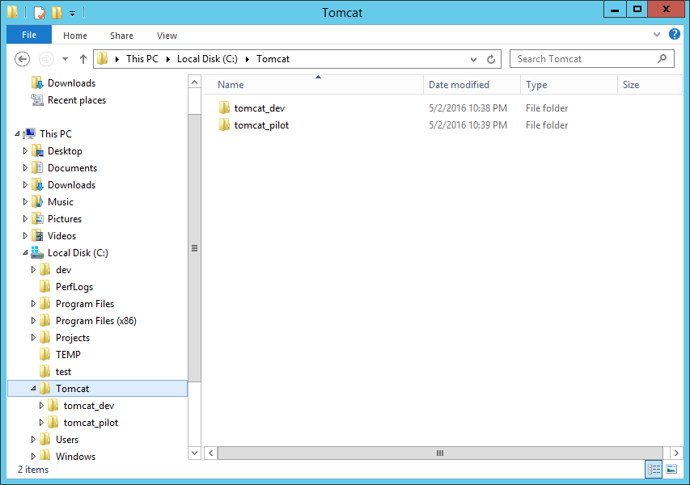

1. Change below HTTP, HTTPS, AJP, Shutdown Ports for tomcat_dev instance in tomcat_dev/conf/server.xml file.

Figure 2: Dev Environment server configuration

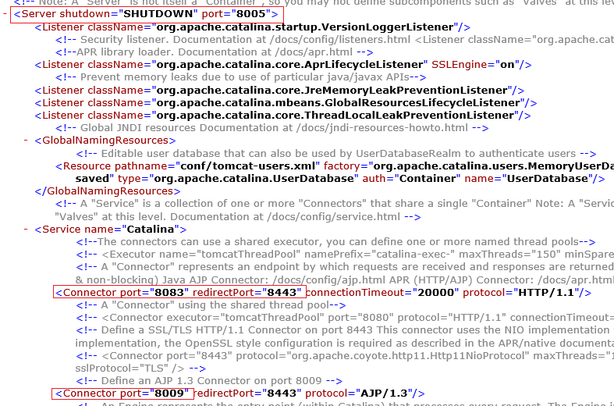

1. Rename startup and shutdown scripts

Figure 3: Dev Environment scripts

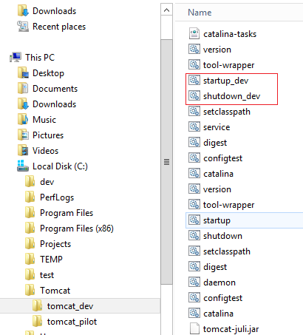

#### Pilot Environment setup

1. Create a Dev Tomcat Instance under C:\Tomcat\tomcat_pilot folder

Figure 4: Pilot Environment tomcat folder



1. Change below HTTP, HTTPS, AJP, Shutdown Ports for tomcat_pilot instance in tomcat_pilot/conf/server.xml file.

Figure 5: Pilot Environment server configuration

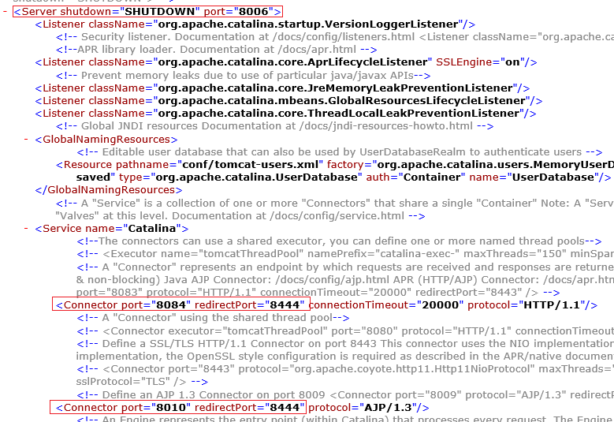

1. Rename startup and shutdown scripts

Figure 6: Pilot Environment scripts

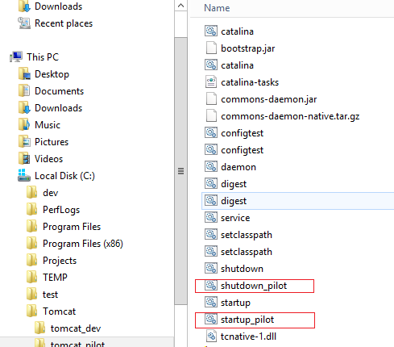

# Installing and Updating the BCDSS Databases

## Script Components

The following database script should be executed against the BCDS database platform for creating all the database objects required to run the application:

* RBAC_DDL_Script_05092016.sql
* DDM_DDL_Script.sql

## Prerequisites

**Note:** Oracle provides 32-bit (x86) and 64-bit (x64) versions of Oracle Database for Microsoft Windows. The 32-bit database version, which this installation guide describes, runs on the 32-bit version of Windows on either x86 or x64 hardware. Oracle provides limited certification for 32-bit Oracle Database Client on 64-bit Windows (x64). For additional information, visit the My Oracle Support (formerly Oracle*MetaLink*) at: <https://support.oracle.com/>

### Minimum Hardware Component Requirements for Windows 64-Bit

| **Requirement** | **Value** |
| --- | --- |
| Physical memory (RAM) | 1 GB minimum |
| Virtual memory | Double the amount of RAM |
| Disk space | Total: 5.22 GB  See [Table 2-3](https://docs.oracle.com/cd/B28359_01/install.111/b32006/reqs.htm#CHDHHGBB) for details. |
| Processor | AMD64, or Intel Extended memory (EM64T) |
| Video adapter | 256 colors |

## Database Installation Procedure

Download the software’s from edelivery.oralce.com and put them into a single folder. Extract them and click on the setup file. No need to supply any email address and click on next.

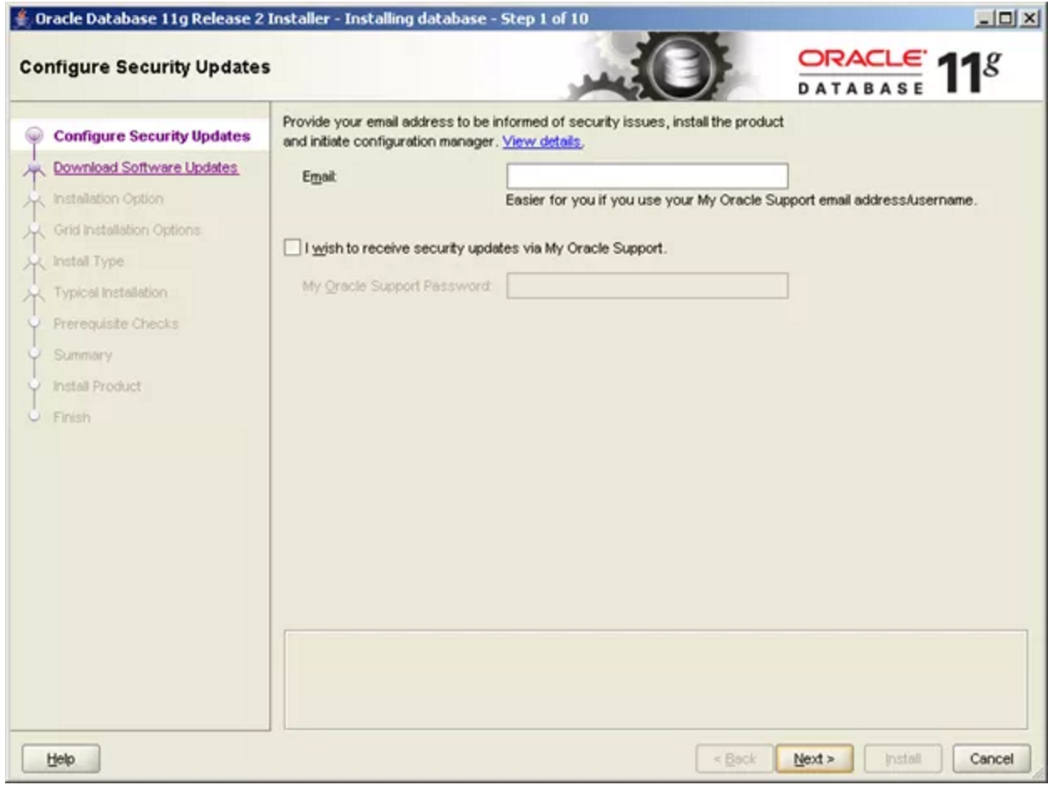

Click on Yes

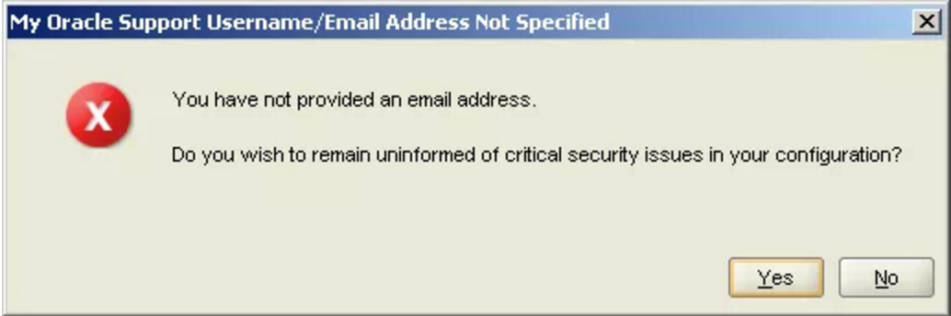

Select skip software updates and click on next.

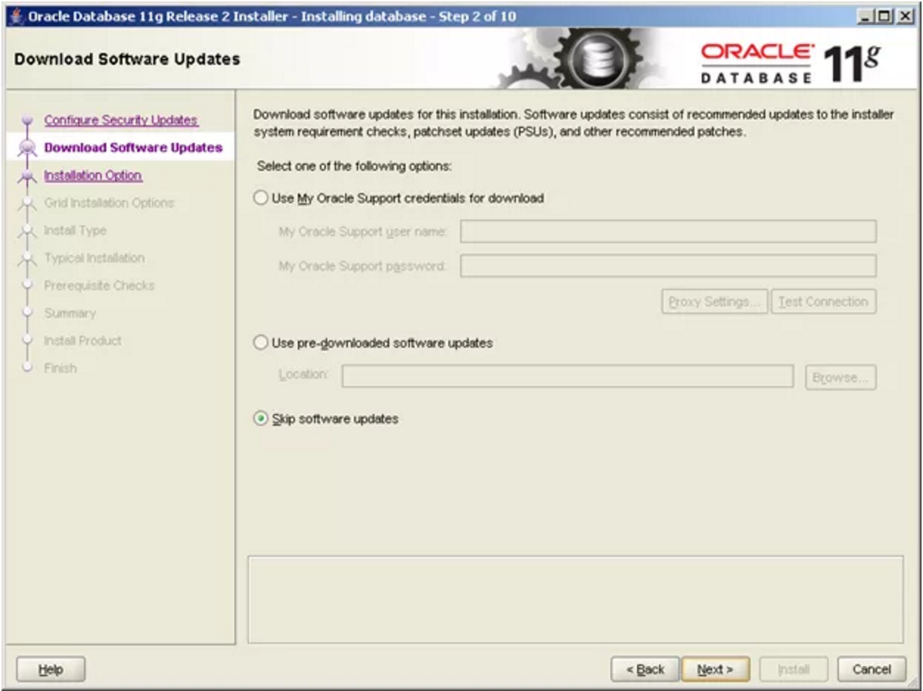

Keep the default settings like below and click on Next

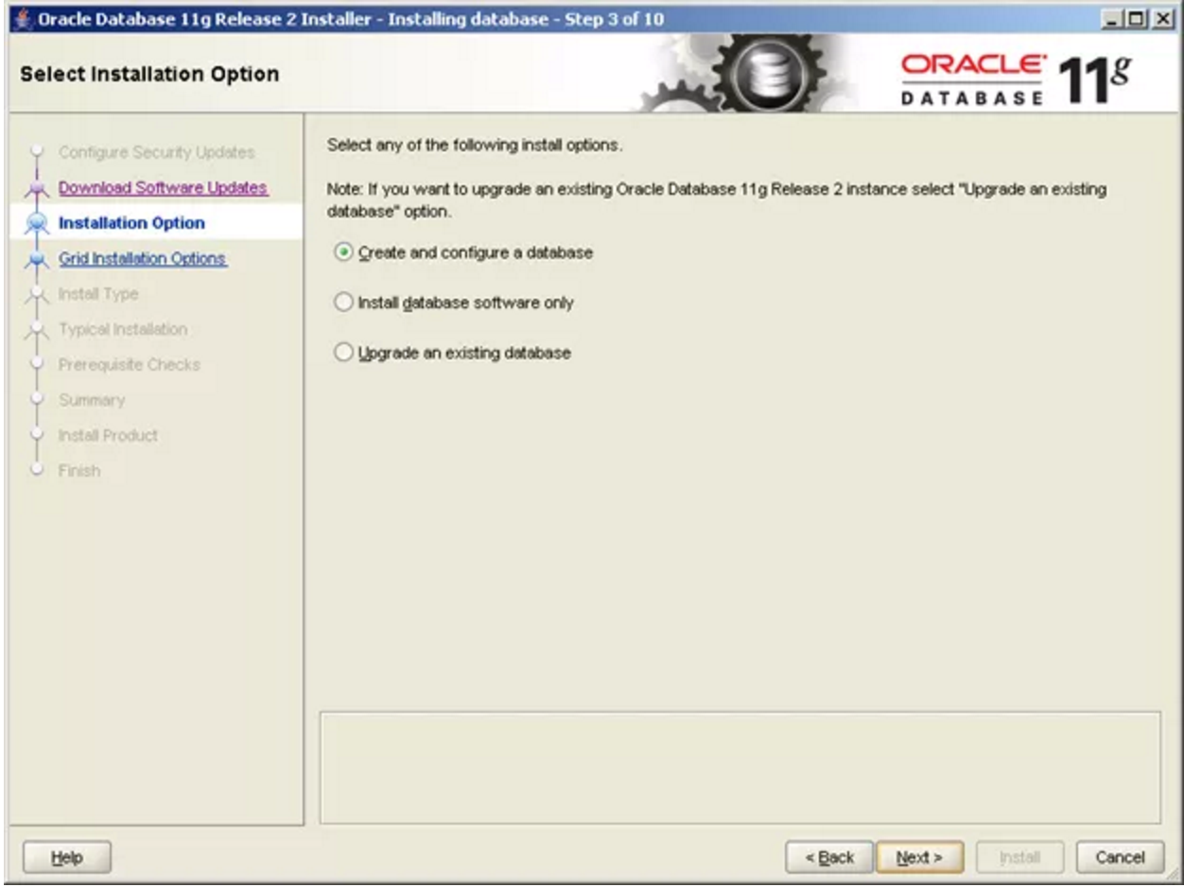

Depending on your requirement choose the option. Desktop class- contains normal standalone DB and server class contains RAC, backup, recovery etc. Here we will choose desktop class

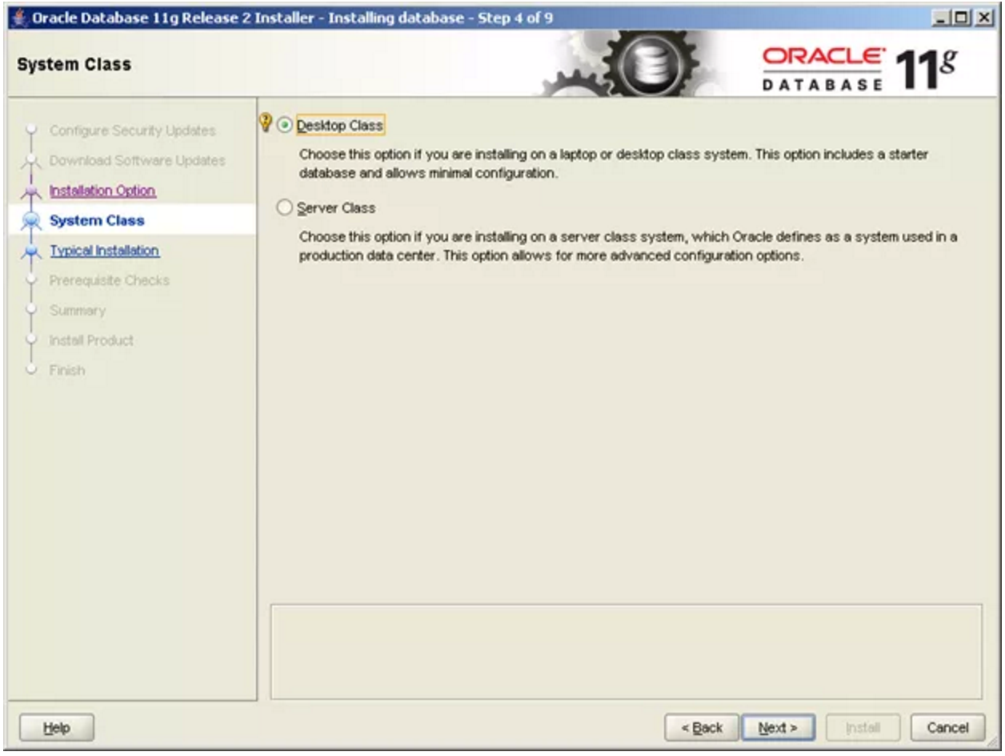

Fill out the details like below and click on next

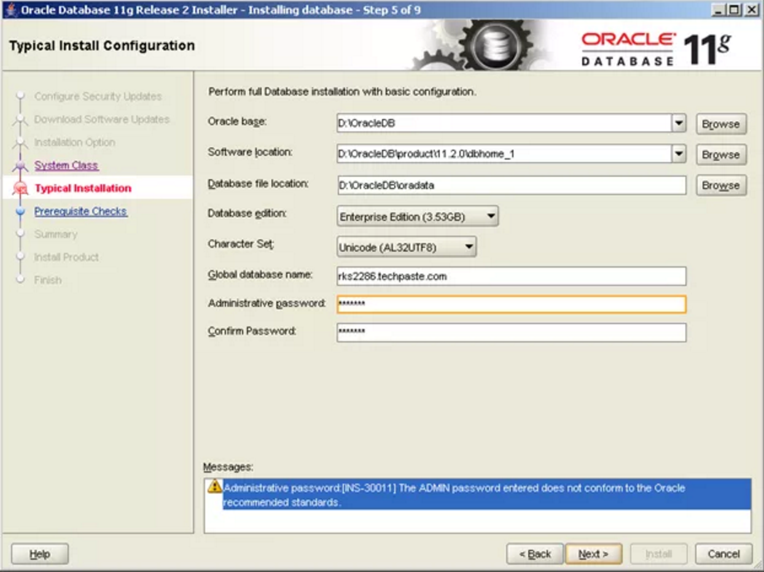

Wait till checks are completed.

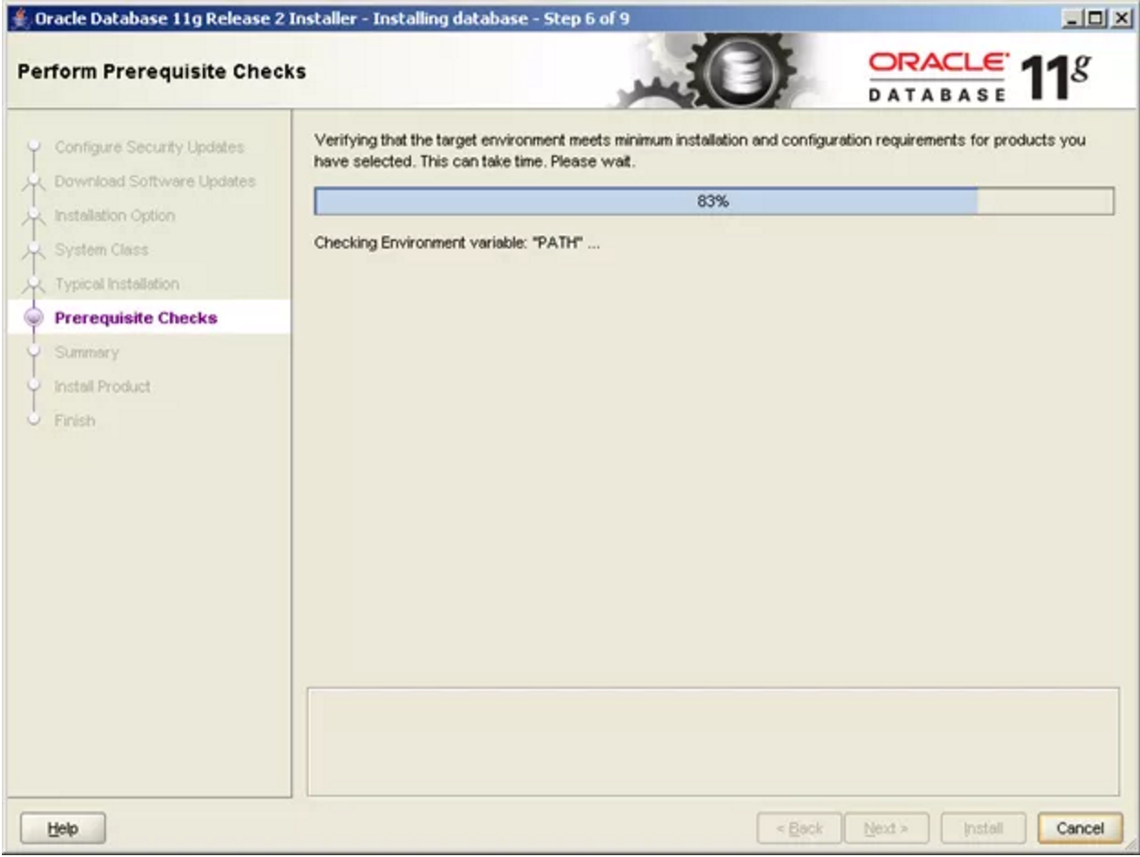

Click on install to start the installation.

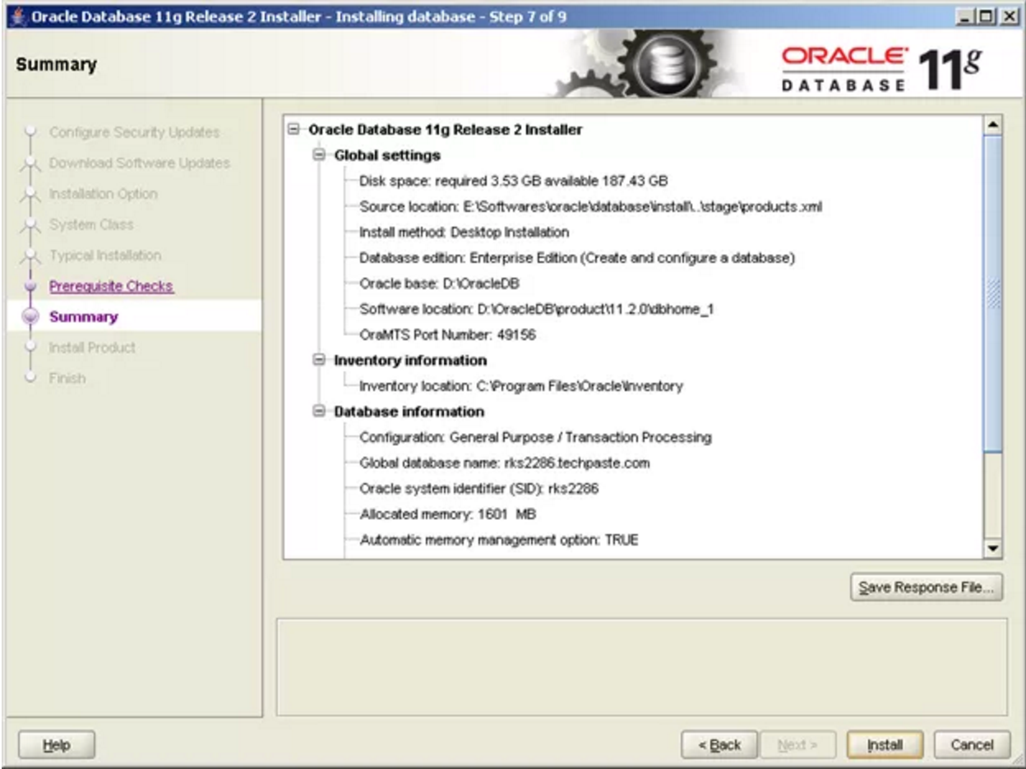

Wait till the installation completes

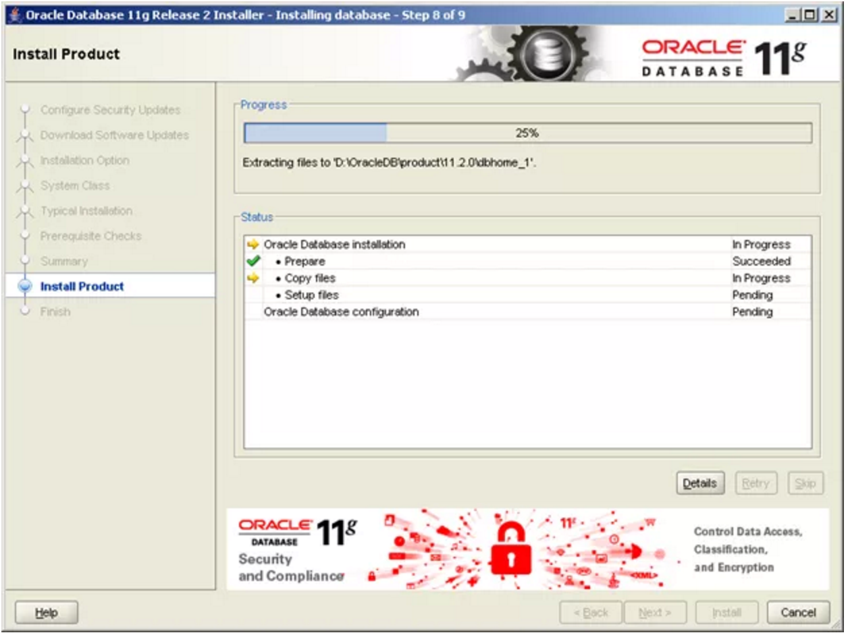

If in installation middle you see any popups saying allow access to network the select Yes so that installation can proceed.

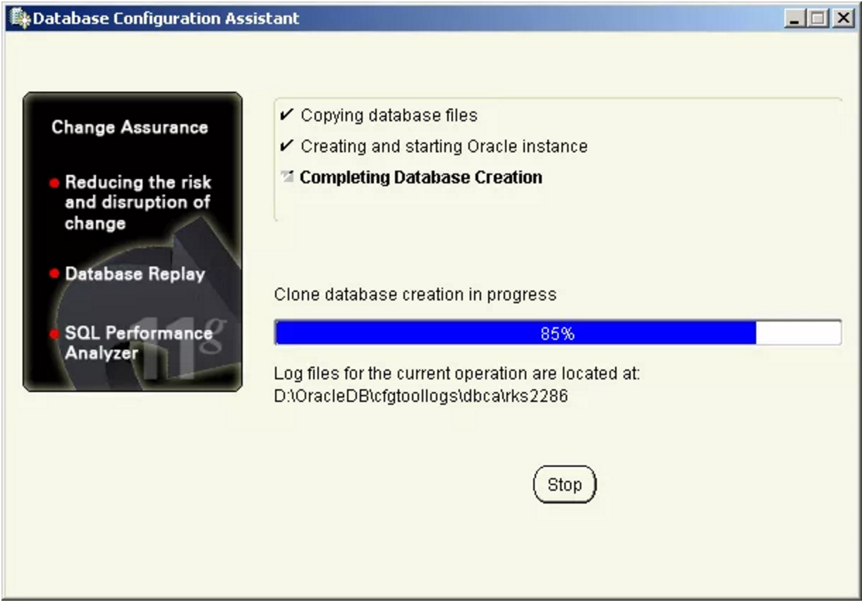

Once you see below screen click on OK

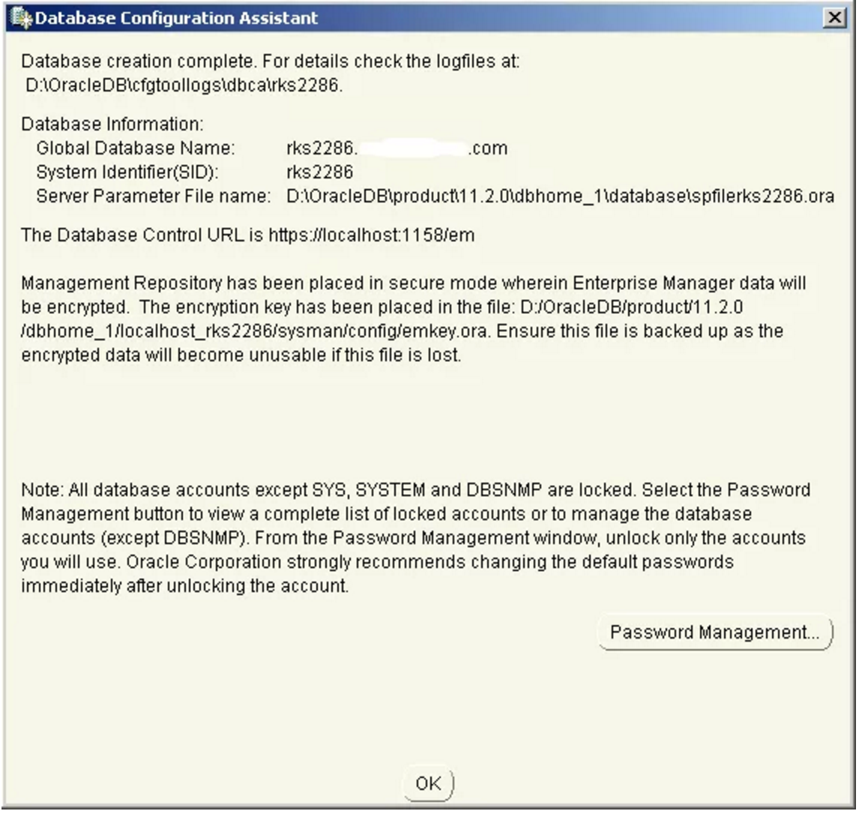

Click on close to complete the installation

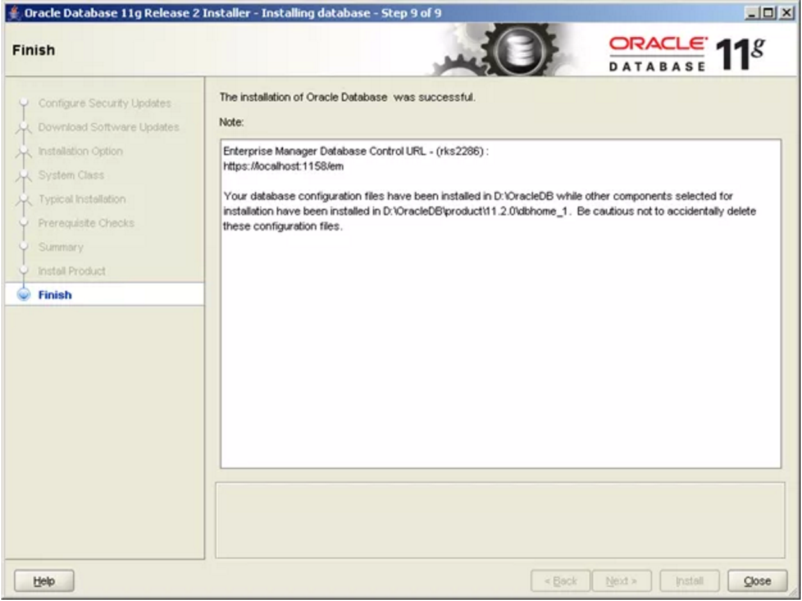

  Click on close to complete the installation



## Database Update Procedure

TBD

## Uninstall the BCDSS Database

TBD

# Deploying the Application

This section provides instructions for deploying the BCDSS application to the Dev & PILOT Environments.

## Overall Pre-Deployment Assumptions

The following conditions must be met before performing a BCDSS deployment:

* Upload the project artifacts (JAR, EAR files) to staging environment folder.
* Verify JAR and EAR files are loaded in the staging environment folder.
* Upload the project documentation deliverables to an internal directory workspace.
* Apply the Liquibase DatabaseChangeLogs to the target database. A Changeset can be seen as everything needed to migrate from one version of the database to another.
* This requires corresponding SQL-statements that are grouped and are then executed together.

## Deployments to Dev

Continuous Integration (CI) builds are automated through Jenkins pooling task. CI build artifacts will be deployed on Development Integration environment using Jenkins jobs. Jenkins sends failure notification to development team for all build and deployment failures.

Figure 7: Dev Deployments Dashboard

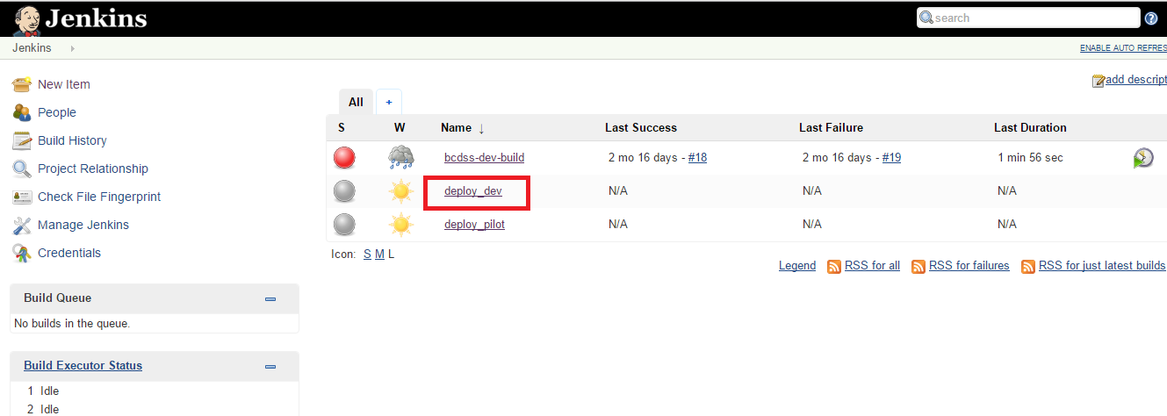

BCDSS team uses the following tools for development integration environment deployments.

* Jenkins tool for Web application deployments
* Liquibase for database changes

## Deployments to PILOT

### Additional Pre-deployment Assumptions

* Update the pilot database configurations in environment specific properties file.
* Upload the project artifacts (JAR, EAR files) to pilot staging environment folder.
* Verify JAR and EAR files are loaded in the staging environment folder.

### Configure Deployment Properties

The profile based configuration file in the persistence /resources directory contains data source information. The standard build will utilize application-local.yml, update it to application-test.yml for pilot environment.

### Deploy BCDSS

Sprint candidate builds will be deployed to Pilot environment at the end of the each sprint (every 2 weeks).

Figure 8: Pilot Deployments Dashboard

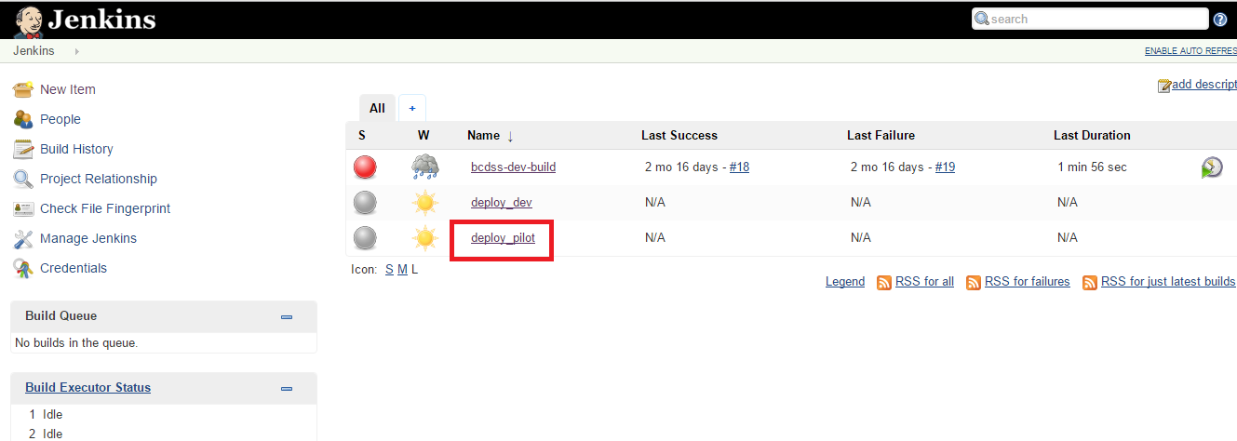

BCDSS team uses the following tools for development integration environment deployments.

* Jenkins tool for Web application deployments
* Liquibase for database changes

## Verify Application Availability and Version

* Perform the following application sanity check steps
  + Access BCDSS application home page.
  + Login as test user and verify the version number located in the footer.

# Release Plan

This section provides an overview of releasing the BCDSS application.

1. Parallel development is supported via multiple code streams in the repository tool, ***Use our tool***.  A release is delivered to production every **#####**.
2. Continuous integration is supported by automated builds and deployments to the Dev environments.
3. Sprint release code changes are built then deployed to Dev → PILOT.
4. Every two weeks a sprint release is deployed to the PILOT environment.  This is a process threshold.  All deployments to PILOT require a release audit which includes:

# Appendices

The following appendices supply additional information about this document.

1. Terminology

The following table lists the terminology used in this document.

|  |  |
| --- | --- |
| **Acronym** | **Definition** |
|  |  |

1. References

The following documents are referenced in this document and/or provide information that augments the information in this document:

# Attachments

1. Approval Signatures

This section is used to document the approval of the BCDSS Software Installation Guide during the Formal Review. The review should be conducted face to face where signatures can be obtained “live” during the review.

If unable to conduct a face-to-face meeting then it should be held via LiveMeeting and concurrence captured during the meeting. The Scribe should add /es/name by each position cited.

The Business Sponsor and Project Manager are required to sign.

REVIEW DATE:

SCRIBE:

______________________________________________________________________________

Signed: Date:

< Business Sponsor >

______________________________________________________________________________

Signed: Date:

< Project Manager >